**COMET BAY COLLEGE**

**Physics Unit 3 – Task 3**

**Circular Motion Validation Test**

**Name: SOLUTION Total Marks /35**

**Part A** has to be handed in at the **commencement** of this test.

Standard school penalties apply for not meeting the deadline.

|  |  |
| --- | --- |
| Part A | /15 |
| Part B | /35 |
| Total | /50 | % |

1. Reflecting back on the experiment you completed what did the trend of your experiment suggest about the relationship between the centripetal force and the radius. (1 mark)

**Regardless of the radius the centripetal force remained constant (1 mark)**

___________________________________________________________________

1. Assuming that the stopper was perfectly horizontal during the experiment, discuss two errors and in detail, how they would affect the results. (4 marks)

**Reasonable error (1 mark)**

**Detailed explanation, include expected changes to values or trend (1 mark)**

_____________________________________________________________________________________________________________________________________________________________________________________________________________________________________________________________________________________________________________________________________________________________________________________________________________________________________________________________________________________

1. Using your knowledge of centripetal force explain how this type of experiment could be relevant to the real world and improve society. (4 marks)

**Reasonable field of study (1 mark)**

**Detailed on how it could be used (1 mark)**

**Detail on how this improves society (1 mark)**

_____________________________________________________________________________________________________________________________________________________________________________________________________________________________________________________________________________________________________________________________________________________________________________________________________________________________________________________________________________________

A group of students in your class (Max, George and Rachael) are also conducting an experiment where a rubber stopper was whirled around in a horizontal plane, as shown below. However, in their experiment the radius was to remain constant, but the hanging mass changed.

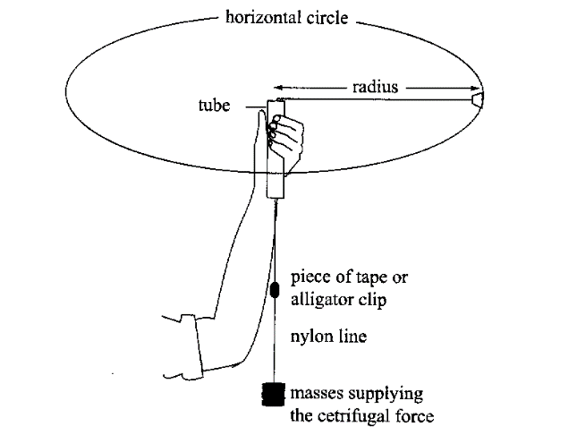

The following results were recorded.

1. Complete the line of data. (working space below table ) (4 marks)

**Table 1: Recorded data of stopper revolving with a variable mass and a radius of 0.6 m.**

**Table 1: Recorded data of stopper revolving with a variable mass and a radius of 0.6 m.**

|  |  |  |  |  |  |  |  |
| --- | --- | --- | --- | --- | --- | --- | --- |
| **Mass (kg)** | **Calculated Centripetal Force (N)** | **Time for 20 turns** | | | **Average time per turn (s)** | **Velocity**  **(m s-1)** | **Velocity2**  **(m2 s-2)** |
| **Trial 1** | **Trial 2** | **Trial 3** |
| **0.2** | **1.96** | **10.42** | **11.21** | **9.75** | **0.523** | **7.22** | **52.1** |

**1 mark each value correct**

**Pay follow through marks for v and v2 if incorrect time is used but only if calculations are shown that support them.**

|  |  |  |  |  |  |  |  |
| --- | --- | --- | --- | --- | --- | --- | --- |
| Mass (kg) | Calculated Centripetal Force (N) | Time for 20 turns | | | Average time per turn (s) | Velocity  (m s-1) | Velocity2  (m2 s-2) |
| Trial 1 | Trial 2 | Trial 3 |
| 0.2 |  | 10.42 | 11.21 | 9.75 |  |  |  |

1. Assuming the students used a metre ruler with mm graduations and a stopwatch which measures to 1/10th of a second, calculate the percentage uncertainty for the velocity calculation. (4 marks)

**Calculation involves $v = \frac{2π r}{T}$**

**(Calculation is a division, therefore must add percentage uncertainties.) (1 mark)**

**Calc % unc**

$T =\frac{0.05}{10.45}x\frac{100}{1}$**= 0.478 % (1 mark)**

$r =\frac{0.0005}{0.6}x\frac{100}{1}$**= 0.083 % (1 mark)**

**Add together 0.478 % + 0.083 % = 0.56% total (1 mark)**

**NOTE - There is no extra uncertainty added by using averages, or dividing by 10**

1. Halfway through using the 200 gram mass, it was misplaced. So the students had to start over, but this time they had no way of measuring the mass. So the students completed the experiment, but they used a different mass and still with a constant radius of 0.600 m. They plotted the attached graph.

Analyse their graph and data to determine the mass of the rubber stopper used. Show all necessary calculations and logic. (7 marks)

|  |  |
| --- | --- |
| Velocity Squared  (m2 s-2) | Force  (N) |
| 6.5 | 0.5 |
| 20 | 1.5 |
| 33.5 | 2.5 |
| 47 | 3.5 |
| 59 | 4.5 |
| 74 | 5.5 |

**Since Fc = m = $\frac{F_{c} r }{v^{2}}$ = r $\frac{F_{c} }{v^{2}}$ indicating how to use the graph (1 mark)**

**Line of Best Fit Drawn (1 mark)**

**Clearly using the graph line of best fit to find the gradient (either plotting on graph or listing coordinates used that do not match table) (1 mark)**

**e.g. (72, 5.4) & (8, 0.6)**

**Gradient = $\frac{F_{c} }{v^{2}}$ = $\frac{rise }{run}$ = $\frac{5.4-0.6 }{72-8}$ = 0.075 (1 mark)**

**Units: N s2 m-2 (1 mark)**

**m = r $\frac{F_{c} }{v^{2}}$ = 0.6 × 0.075 (1 mark)**

**m = 0.045 kg (1 mark)**

1. One of the major errors of this experiment is that the mass is not spinning horizontally. Briefly describe how this can affect the experiment? (3 marks)

______________________________________________________________________________________________________________________________________________________________________________________________________________________________________________________________________________________________________________________________________________________________________________________________________________________________________________________________________________________________________________________________________________________________________________________________________________________________________________________________________________________________

**Decreased REAL radius 🡪 Means CALCULATED velocity will be higher than REAL. (1 mark)**

**Because plotted Velocities (X Axis) will be higher than real, Gradient will be lower than real. (1 mark)**

**Because the gradient will be lower than real, the calculated value for the mass of the stopper will also be lower than REAL.(1 mark)**

1. What is an appropriate aim for this experiment (2 marks)

**To study how force is affected (1 mark) when changing the mass for an object moving in a circular path (1 mark)**

______________________________________________________________________________________________________________________________________

1. What is an appropriate hypothesis for this experiment (3 marks)

**Statement: (2 marks)**

**e.g. An unbalanced force must act on an object moving in a circular path.**

**e.g. This force is inversely proportional to the radius and directly proportional to the mass and velocity squared.**

**Prediction: (1 mark)**

**e.g. Therefore as the radius increases then the force experienced will also increase.**

_______________________________________________________________________________________________________________________________________________________________________________________________________________________________________________________________________________________________________________________________________________

1. Complete the following:
2. Independent Variable: (1 mark)

**The mass of the object moving in a circular path (kg)**

**The time to complete 20 rotations (s)**

**The circular motion of the rubber stopper remaining horizontal**

**The same 0.6 m radius of the string holding the stopper**

________________________________________________________________

1. Dependent Variable: (1 mark) ________________________________________________________________
2. Controlled Variables: (1 mark) ________________________________________________________________________________________________________________________________